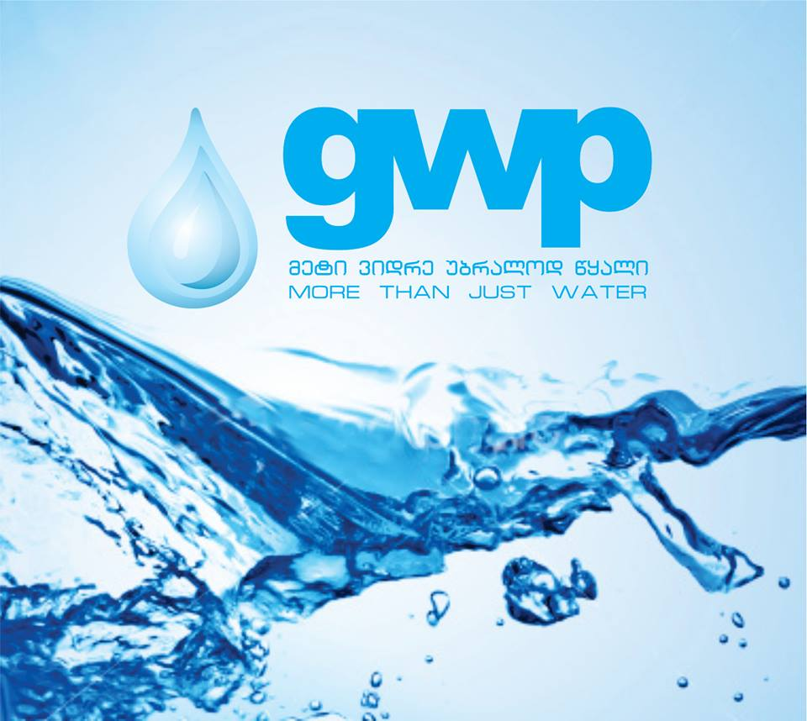  Technical Assignment  Waterproof´s proyect design for Chatma Reservoir | Abstract  Develop the project for waterproofing Chatma Reservoir.

Table of Contents

1. Project Overview 2
2. Introduction 2
3. Scope of Supply 2
Appendix: Visual inspection of water reservoirs located near Chatmi mountain in city Rustavi. 3

Project Overview

- Project Name: Chatma´s waterproof project.
- Location: Rustavi.

- Number of reservoirs: 1 pieces.
- Client/Owner: GWP
- Date: 4/Jul/2025

2. Introduction
The Chatma reservoirs are located in the city Rustavi, near the Chatma mountain, on the left bank, in the territory of "Georgian Water and Power" ( 02.05.01.383 ). The total area of the territory is 46,727.00 m2.
The reservoirs are underground and concrete. One of them is round and two are square. The reservoirs are at 399 meters above sea level ( 41°34'21.4"N 45°00'44.0"E. ). The dimensions of the rectangular reservoir are 60X25X5 m, it´s identify in the attached annex as a Reservoir number 2. The volume of the reservoir is aproximatly 6000 m3. They supplies the part of the right bank of the city of Rustavi and the settlement of builders. The reservoirs were built in stages from 1950 to 1970.
This document outlines the requirements for the outsourcing of the project development for waterproofing and internal cracks repair the Chatma reservoir in Rustavi, identify in the attached documentation as Reservoir number 2.
Objective:
- Project for the waterproofing and internal reparation of cracks and pipes in Chtama reservoir, including all the necessary steps, process and BOQ, for achieve this object. This project must be elaborated based on Resources Catalogue (snip) prices, in those cases that it´s not possible to be done under snip prices must be done an expertise.

3. Scope of Supply
Complete project for waterproofing Reservoir Nº 2:
- Reservoir drawings.
- Works to project:
  - Cleaning and treatment of the stripped reinforcement bars of reservoir structures with anti-corrosion material.
  - Treatment of cracks on reservoir walls and invert should be carried out according to the degree of damage and opening width.
  - After the treatment of the cracks, the layer of reinforced mortar should be arranged on the water reservoir invert.
  - A new insulating layer should be arranged on the invert and walls with a waterproofing material, applicable for drinking water reservoirs.
  - To improve the damaged drainage system of water reservoir No.1, it is necessary to replace the damaged well.
A site visit is obligatory for identifying all the necessary information to elaborate on the design projects.

The documents presented in this tender are presented only for informational purposes and if the bidder considers necessary to make any other surveys in order to elaborate the project, the cost of the all such surveys should be included separately on financial proposals.
Documentation:
- Visual inspection of water reservoirs located near Chatma mountain in city Rustavi.
- Geological survey of the reservoir

Appendix: Visual inspection of water reservoirs located near Chatmi mountain in city Rustavi.

