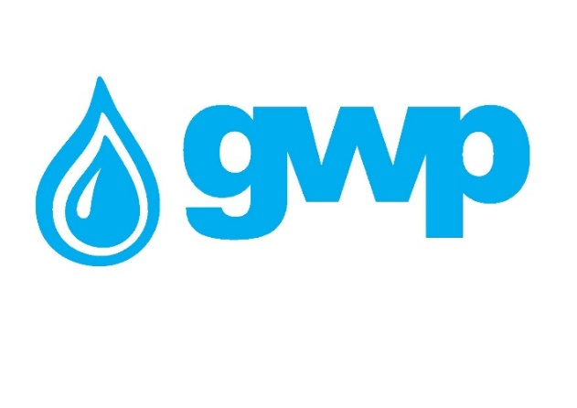

**E-Tender Documentation of the purchase of the automation project for pumping stations**

**1.1 Title of procurement**

Georgian Water and Power LLC (GWP C/C 203826002), announce electronic tender for the purchase of automation project for pumping stations**.**

**Note:**

The purpose of the tender is to select the company for providing the project given in Annex N1 (Technical assignment for each station in per sheet)

Chosen company/winner Company should present the project after signing the contract no later than in 1 month

**🔷 1. Title of project:**

**Automation of Pumping Stations**

**________________________________________**

**🔷 2. Objective:**

**The objective of this procurement is to implement an automation project for pumping stations to improve operational process management, increase system reliability, and reduce the need for manual intervention. The ultimate goal of the project is to fully integrate the automation systems with a SCADA platform, enabling efficient remote monitoring and control.**

**________________________________________**

**🔷 3. Scope of Work:**

**• Preparation of design solutions for the automation of pumping stations**

**• Supply of RTU devices and necessary automation equipment**

**• Installation, assembly, and commissioning of the system**

**• Provision of technical support, as described in the attached technical requirements and specifications**

**________________________________________**

**🔷 4. Implementation Approach:**

**The project will be implemented in phases, covering several pumping stations. While detailed technical requirements and descriptions are provided in the attached files, the preparation of design solutions is part of the procurement scope.**

**________________________________________**

**🔷 5. Expected Results:**

**• Reliable and stable operation of automated pumping stations**

**• Improved operational efficiency and maintenance management**

**• Full readiness for future SCADA integration**

**________________________________________**

**🔷 6. Reference Documents:**

**Detailed technical requirements and descriptions are provided in the annexed files of this TOR.**

**________________________________________**

**🔷 7. Contact Information for Inquiries:**• Names: Levan Jamagidze, Valeri Khachidze, Erekle Matiashvili  
• Phone/Email: +995 558 33 17 33, +995 591 88 46 01, +995 574 12 06 14 / ljamagidze@gwp.ge, vkhachidze@gwp.ge, ematiashvili@gwp.ge.

**1.3 Cost estimation**

A Tender Participant shall provide cost estimation per Annex N2 in PDF and Excel files.

**1.4** **Term of Payment**

Payment shall be made by Bank transfer, within the period of 30 (thirty) calendar days from each submited delivered goods.

**1.5 Information to be uploaded/provided by bidders for electronic tender:**

1. Price list according to Annex   
2. Annex 2 must be filled fully and prices must be include all fees;

3. Extract from the Registry of entrepreneurial and non-entrepreneurial (non-commercial) legal entities issued during **last 3 months** announcement date of the electronic tender.

4. Company’s full requisitions;

5. Company’s experiance of working in the similar projects (recommendation letters, contracts or other documents).

**Note:**1) All documents and/or information uploaded for the electronic tender by a bidder shall be signed by an authorized person (a letter of attorney shall be uploaded whenever required);  
2) It is Preferable All documents and/or information prepared by a pretender to be verified by an authorized person using electronic signature or a stamp of the company.

**1.7 Concluding a contract**

1) A contract with the winner company will be signed in accordance with the terms of this tender.

2) Georgian Water and Power LLC reserves the right to sign a contract with one or more companies.

**1.8 Other requirements**

1.8.1 When submitting a bid, a bidder shall not be:

* in the process of filing for bankruptcy
* in the process of liquidation
* in conditions of suspended business activity.

1.8.2 Cost estimation shall be made in Georgian national currency (GEL). Prices must include all costs considered by this tender and taxes specified by the Georgian legislation.

1.8.3 Offer of the bidder shall be valid for **60 (sixty**) calendar days from the date of its submission.

1.8.4 Georgian Water and Power LLC reserves the right to determine by itself the tender completion time, to change the tender terms under the notification timely given to the bidders, or to terminate the tender at any stage of its progress.

Georgian Water and Power LLC will identify the winner through the tender commission and inform all participating companies thereof. Georgian Water and Power LLC is not obliged to give a verbal or written explanation to any bidder on any decision made regarding to the tender.

Georgian Water and Power LLC reserves the right to verify any information received from the bidders as well as to obtain information about the company or its activities. If the information provided by a bidder is not true or false, the bidder will be disqualified.

Please, note that Georgian Water and Power LLC will not accept oral requests for additional information. Only phone inquiries will be accepted.

***Note: Any other information obtained in any other way will not be considered as official and does not generate any obligation from Georgian Water and Power LLC.***

**1.9 Information for participation in the electronic tender:**

1.9.1Any questions during the electronic tender process shall be made in writing and communicated through the Q&A platform of tenders.ge website;

1.9.2 To participate in the electronic tender, the company shall be registered on [www.tenders.ge](http://www.tenders.ge);

1.9.3 For instruction on participation in the electronic tender through tenders.ge please refer to the attached file.

1.9.4 Participation in the e-tender is **free of charge**.

*In order to exclude any definition, “Georgian Water and Power”," notes that the indicative total volume is one and its indication can not be interpreted in any case as an obligation of “Georgian Water and Power” to purchase goods/services in an indicative total volume. The indicative total volume does not represent the exact volume of goods/services to be purchased during the term of the contract in case of signing the contract, the volume of goods/services actually purchased may differ significantly (be more or less) from the indicative total volume, in such case: (a) the tenderer guarantees that he will not claim damages on this basis and declares his refusal to claim any kind of damages/losses on this basis, (b) This circumstance cannot be the basis for the termination of the contract of “Georgian Water and Power” or the request to change the contractual conditions by the person participating in the tender. By participating in the tender, the tender participant agrees to these terms and has no claims against them.*

**Contact information**:

Contact person: Tamar Vashakidze

Address: 10 Medea (Mzia) Jugeli str., 0179, Tbilisi

E-mail: tvashakidze@gwp.ge

Tel.: +995 577585592