

**The Regional Environmental Centre for the Caucasus**

**TERMS OF REFERENCE**

**Consultancty Services for Pasturelands Identification and REgistration SUpport in Dedoplistskaro Biosphere Reserve**

***Ref. no. 076/RECC/G/UNEP 2025 EA 007***

|  |  |  |  |  |  |  |  |
| --- | --- | --- | --- | --- | --- | --- | --- |
| **Contract Title:** | | **Consultancy Services for Pasturelands Identification and Registration Support in Dedoplistskaro Biosphere Reserve** | | | | | |
| **Contract Type:** | | **Service Contract - Global Price Based** (*Subcontract Service Agreement*) | | | | | |
| **Contracting Organization:** | | | The Regional Environmental Centre for the Caucasus (RECC) | | | | |
| **Division/Department:** | | | RECC Projects’ Implementation Unit | | | | |
| **Programme/Project Number:** | | | | **``Transforming Policy and Investment through Improving Ecosystem Management and Restoration of Degraded Drylands of Dedoplistskaro Biosphere Reserve in Georgia to Generate Multiple Environmental and Socio-Economic Benefits``**  (*GEF Project ID: 11141)* | | | |
| **Duty Station:** | | Tbilisi and Dedoplistskaro Municipalities | | | | | |
| **Expected Start Date of Assignment:** | | | | | September, 2025 | **Duration:** | **4 months**  (up to January, 2026) |
| **Reports to:** | Sophiko Akhobadze | | | | | RECC Executive Director | |

**1. Description OF objectives of the SERVICE**

**1.1. Background**

The Global Environment Facility (GEF)-funded project *“Transforming Policy and Investment through Improving Ecosystem Management and Restoration of Degraded Drylands of Dedoplistskaro Biosphere Reserve in Georgia to Generate Multiple Environmental and Socio-Economic Benefits”* supports ecosystem restoration, biodiversity conservation, and sustainable land use in the Dedoplistskaro Biosphere Reserve.

The project is implemented by the United Nations Environment Programme (UNEP) and executed by the Regional Environmental Centre for the Caucasus (REC Caucasus) on behalf of Georgia’s Ministry of Environmental Protection and Agriculture (MEPA). It runs for four years starting in 2025.

Project component 2 aims to improve ecosystem management and restoration of degraded drylands. Outcome 2.2 – Restoration of degraded ecosystems improves connectivity and enhances biodiversity wll support improvement of pasture management system within the DBR in collaboration with local pasture users. Pastures identification, zoning, categorization (definition of use regimes), and mapping within the BR will be essential for understanding and managing pasture resources effectively. This activity prescribed under the output 2.2.3 will help in identifying suitable areas for different types of land use and ensuring sustainable pasture management practices

National Pasturelands Management Policy Document (NPMPD)[1] discusses the need to formalize livestock owners’ rights to access the pastures to ensures pasturelands sustainable management and, in this regard, considers as a first step the official registration of lands used for pasture or, in the case of registered plots, assigning them the category of pasture. This approach is being considered by the process of development of new pasture management legislation. Pasturelands registration will create a spatial database that is necessary basis for defining pasturelands tenure regimes (common and individual (leasehold) regimes), and therefore to enable all livestock owner to formalize their access to it. The project will provide technical support for pastures identification and registration/categorization in Dedoplistskaro Biosphere Reserve to create a spatial database for informed decisions on pasturelands handover.

The experiences of this project will be replicated across Georgia through activities of national and international partners, and shared with other countries.

**1.2. General Objective of the Service**

The objective of the consultancy service is: **Pasturelands Identification and Registration Support in Dedoplistskaro Biosphere Reserve to create a spatial database for informed decisions on pasturelands disposal.**

Identification and registrations support should cover both unregistered and state or municipally owned plots of land that are registered in the public register as agricultural land without specifying the land category.

Land plots are identified and assigned to the pasture category by following these criteria:

* Land plots identified as pasture land according to district land use maps and/or land use plans of former collective farms and farms as of 1991.
* Land plots registered with unspecified data in the public registry, identified as mowing-pasture land based on cadastral data processed by a special computer program (the so-called "yellow layer").
* Field verification of actual conditions and usage.

Pasturelands should be identified throughout the entire territory of the Dedoplistskaro Biosphere Reserve, except for the Vashlovani Protected Areas and the Chachuna Managed Reserve.

The assignment is to be implemented with overall guidance and supervision of the RECC Executive Director (Project Director/Supervisor), in close consultation with the Ministry of Environmental Protection and Agriculture of Georgia (MEPA), the National Agency for Sustainable Land Management and Land Use Monitoring (NASLM) and Dedoplistskaro Municipality, in cooperation with the project national consultants on pasture assessment and planning.

RECC will ensure that the local authorities are informed on this survey. RECC will make available to the consultant relevant reports, documents, maps and data at RECC’s disposal.

**2. Scope of the SERVICE**

Consultant Entity is expected to implement tasks within this assignment in coordination with the RECC project implementation team and experts, the National Agency for Sustainable Land Management and Land Use Monitoring (NASLM) and Dedoplistskaro Municipality.

Under this Scope of Work, the Consulting Entity shall perform the following tasks:

***a. To create integrated GIS database of nominally state owned but still unregistered land plots and land plots registered without indication of particular agricultural land category in Dedoplistskaro Biosphere Reserve that could be registered as pasturelands***

According to the pasture database (prepared based on the archival land use plans of former public farms in Dedoplistskaro Municipality, in total approximately 8,125 ha of pasturelands is registered without assigning the category and 4,270 ha pasturelands is not registered within the Dedoplistskaro Biosphere Reserve (outside of the Vashlovani and Chachuna Protected Areas).

The consultant entity, in close cooperation with project experts, National Agency for Sustainable Land Management and Land Use Monitoring and Dedoplistskaro Municipality, should revise and update obtained data and develop integrated GIS dataset of pasturelands distribution in Dedoplistkaro municipality. After the completion of this task all (i) not registered land plots that could be registered as pastures and (ii) all registered land plots that could be recommended for assign the category of pastures, should be specified for further field verification.

***b. Field verification of nominally state owned but still unregistered land plots and land plots registered without indication of particular agricultural land category in Dedoplistskaro Biosphere Reserve that could be registered as pasturelands***

Field verification of identified nominally state owned but still unregistered land plots and land plots registered without indication of particular agricultural land category used as pastures include but is not limited to:

- 4,270 ha not registered land plots

- 8,125 ha registered land plots registered without assigning the category.

The indicative distribution of the above-mentioned pastures in the Dedoplistkaro Biosphere Reserve is presented in Annex 1.

Field verification of identified nominally state owned but still unregistered land plots and land plots registered without indication of particular agricultural land category used as pastures include but is not limited the following activities:

* Consultations with municipality representatives and local users further clarification of identified pastures to be registered and/or categorized;
* Determination of de-facto use of the identified pasturelands by field verification;
* Cadastral surveying/measurements of land parcels and searching for field data in accordance to the resolution N388 of the Government of Georgia adopted on August 8, 2016: "Approving the procedure for performing and documenting the cadastral planning/measurement work of the land plot and the procedure for suspending and revoking the validity of the certificate of the person authorized to perform the cadastral planning/measurement work for performing the cadastral planning/measurement work in violation of the requirements of the Georgian legislation";
* When performing cadastral planning/measurement works of the pasturelans, the cadastral survey drawing should not include those areas, the actual situation of which excludes the use of the mentioned areas as the pastureland, in particular, following structures: a) buildings; b) perennial agricultural crops; c) objects of communication; d) infrastructure functionally related to communication objects (business yards, main irrigation canals, roadsides, drainage canals, electric transmission or communication towers (supports), etc.).

***c. Preparation of documentation necessary for land registration and proposals for changes in the registered land title data***

The consultant entity, in close cooperation with project experts, shall prepare:

1. Documentation necessary for land plots registration (*including cadastral planning/measurement drawings of the land*), both in material (paper) and electronic form for all identified pasturelands that are not registered.
2. Refined georeferenced spatial database of land plots that are already registered by the National Agency of Public Registry (NAPR) in state or municipal ownership as agricultural lands without indication of particular agricultural land category aimed at granting the category of ``pasture`` to them. For each registered plot of land, digitized boundaries of the part of the land plot that is recommended for pasture category assignment and descriptions of the de-facto use identified on the basis of field verification should be prepared and submitted.

**4. DELIVERABLES AND REPORTING SCHEDULE**

The estimate duration of the assignmnet is 4 months. The services will be commenced in September, 2025.

The Consulting Entity will submit reports to the following deliverables indicated in Table 1.

**All deliverables should be submitted in Georgian languages.**

*Table 1. Reporting Obligations*

|  |  |  |
| --- | --- | --- |
| **Report Index** | **Name of Deliverable/Means of Verification** | **Time of Submission** |
| R1 | Technical Report on development of integrated database of nominally state owned but still unregistered land plots and land plots registered without indication of particular agricultural land category in Dedoplistskaro Biospehre Reserve that could be registered as pasturelands, including maps and georeferenced spatial dabases for:   1. Land plots registered under the pasture category within the biosphere reserve (indicated by cadastral codes and areas); 2. State or municipal owned land plots registered within the biosphere reserve but without indication of land category, which are identified as pasture (indicated by cadastral codes and areas); 3. Unregistered plots within the biosphere reserve, which are identified as pasture (georeferenced spatial database of pastures to be registered. | September, 2025 |
| R2 | a) Documentation necessary for land plots registration (including cadastral planning/measurement drawings for land plots for all identified pasturelands that are not registered.  b) Refined georeferenced spatial database of land plots for preparation of proposals on technical changes in registered land title data aimed at granting the category of “pasture” to those plots of agricultural lands which are already registered by the National Agency of Public Registry (NAPR) in state or municipal ownership as agricultural lands without indication of particular agricultural land category. | September-November, 2025 |
| R2-A | Documentation a) and b) for land plots located in 5 administrative units of Dedoplistskaro Municipality | September-November, 2025 |
| R2-B | Documentation a) and b) for land plots located in 5 administrative units of Dedoplistskaro Municipality | September-November, 2025 |
| R2-C | Documentation a) and b) for land plots located in 4 administrative units of Dedoplistskaro Municipality and land plots located in Dedoplistskaro Municipality but owned by Akhmeta Municipality | September-November, 2025 |
| R3 | Final thematic map and GIS database of pasturelands to be registered/to be categorized in the Dedoplistskaro Biosphere Reserve both in electronic and physical form printed on A0 format, at least 5 copies. | December, 2025 |

All deliverables are subject for review and approval by the RECC.

# 5. Payment Schedule

The Consulting Entity shall submit to the RECC the deliverables in the form and within the time periods specified in Table 1 (Reporting Obligations) as per Terms of Reference, acceptable to the RECC. The payment mode for the service will be applied based on delivered reports and acts of acceptance (*Service Delivery Acceptance Acts*) signed by both sides (RECC andConsulting Entity) and submitted by the Consulting Entity of original invoices to the RECC.

The Consulting Entity and its team will make their own arrangements on transport, security and accommodation and meals during the duration of the service (assignment).

RECC will only make milestone payment based on achievement of specific deliverables as specified in time schedule for submission of deliverables as per Table 1 (Reporting Obligations).

The schedule of payments is specified below:

*Table 2. Schedule of Payments*

|  |  |
| --- | --- |
| **Report Index for Deliverables** | **Amount of Transfer**  **in % of total contract ceiling for the Services**  **(*total Value of the Service*)** |
| **R1** | **20%** |
| **R2-A** | **20%** |
| **R2-B** | **20%** |
| **R2-C** | **20%** |
| **R3** | **20%** |
| ***Total*** | **100%** |

**Final Settlement Clause**

The contract price stipulated in the tender shall be subject to adjustment based on the actual quantity of work performed, as measured in accordance with the procedures set out in the Contract and recorded in the Final Acceptance and Delivery Act. If the actual measured area is greater or less than the area specified in the tender, the contract price shall be increased or decreased accordingly, using the unit rate per area specified in the tender. The adjusted amount shall be reflected in the final payment.

**6. CONSULTING ENTITY’S QUALIFICATIONS AND EXPERIENCE**

**Eligibility for Participation**. Subcontracting for this assignement is allowed for commercial services of for-profit entities (*registered in Georgia according to the law of Georgia ``On Entrepreneurs``*).

* The consulting entity shall have at least 5 years’ experience in performing of land cadastral survey and preparation of cadastral planning/measurement drawing for land plots;
* The consulting entity must specify the qualifications and experience of each specialist to be assigned to the preforming of tasks in accordance of ToR;
* The specialist/specialists for carrying out cadastral survey/planning works should be certified by an entity duly accredited by a Legal Entity under Public Law called the Accreditation Centre of the Unified National Body of Accreditation in accordance with the requirements of the Legislation of Georgia in accordance with law on ``The Public Registry``.
* The consulting entity will be able to demonstrate – trough the curriculum vitae of its team its experience with the professional preparation of documentation for land registration and performing of field verification works;
* Practical experience and familiarity in data gathering and processing on agricultural land (including pasturelands);
* Experience in GIS linked data systems, their operation and analyses;
* Specific Knowledge of land categories (incl. pasturelands) classification, delineation, land registration;
* The consulting entity’s proposal must include an understanding of the Terms of Reference (TOR) and a description of the proposed approach to the pasturelands identification, mapping and preparation of registration documentation and georeferenced spatial databases in accordance with the TOR.

**7. CONTACTS, COMMUNICATION AND SUPERVISION**

The Consulting Entity will be under the direct supervision of the RECC Project Core Team based in Tbilisi Head Office for the duration of the service. The Consulting Entity will maintain official communication with the RECC Project Core Team.

**8. AWARD CRITERIA**

Evaluation will be made in accordance with the quality/price-based selection method per REC Caucasus procedures and rules. The best value for money will be established by weighing technical quality against price on an 60/40 basis.

When evaluating technical offer of a candidate, a score out of a maximum 100 points could be recievied by the offer in accordance with the technical evaluation grid (setting out the technical criteria, sub-criteria and weightings) laid down in this Terms of Reference (*see below*).

Only offer that achieved a score of 75 or more shall be declared 'technically accepted'.

The quality of a technical offer will be evaluated in accordance with the award criteria and the associated weighting as detailed in the following evaluation grid of this Terms of Reference:

**Evaluation Grid**

|  |  |
| --- | --- |
| *Ref. no.* *076/RECC/G/UNEP 2025 EA 007*  ***Consultancy Services for Pasturelands Identification and Registration Support in Dedoplistskaro Biosphere Reserve*** | |
| **EVALUATION GRID** | **Maximum** |
| **Service Organisation and Methodology** | |
| ***( Max 20 points )*** | |
| Rationale | 5 |
| Strategy | 10 |
| Timetable of activities | 5 |
| **Total score for Organisation and methodology** | **20** |
| **Consulting Entity** | |
| ***Professional experience*** | |
| *At least 5 years experience in performing of land cadastral survey and preparation of cadastral surveying/measurement drawing for land plots* | **20** |
| *Practical experience in data gathering and processing on agricultural land (including pasture land)* | **20** |
| **Experts** |  |
| **Leading GIS expert** |  |
| ***Professional experience***  *At least 15 years proven experinece**in GIS linked data systems, their operation and analyses;*  *Specific Knowledge of land categories (incl. pasturelands) classification, delineation, land registration.* | **20** |
| ***Surveyor*** |  |
| *At least 5 years proven experinece in performing of land cadastral survey and preparation of cadastral surveying/measurement drawing for land plots*  *Certificate authorized to perform cadastral surveys/planning* | **20** |
| **Total score for Consulting Entity** | **80** |
| **Overall total score** | **100** |

**Annex 1: Territories Used as Pastures in Dedoplistskaro Biosphere Reserve**

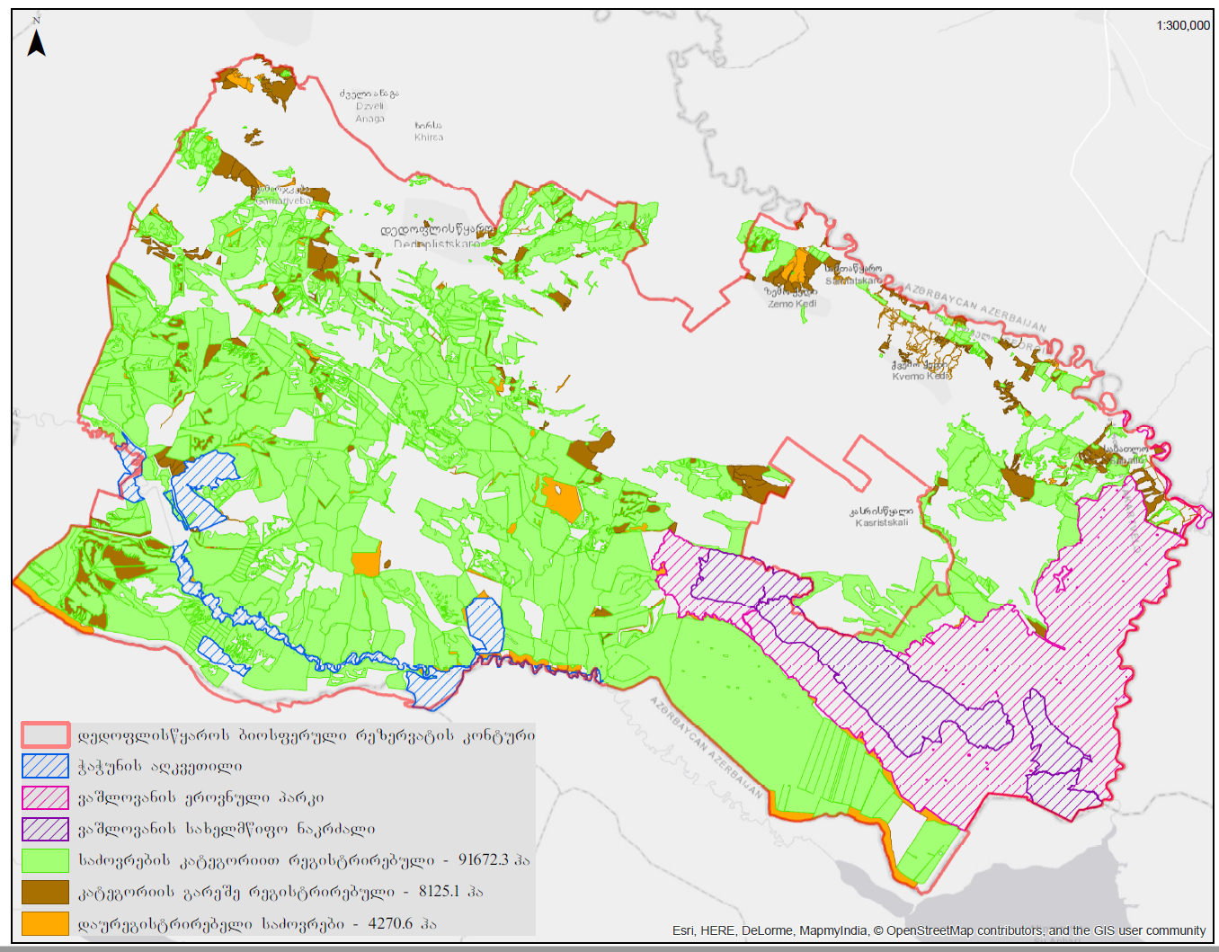

Map 1: Spatial distribution of pasturelands to be registered/to be categorized in the Dedoplistskaro Biosphere Reserve

1. <https://mepa.gov.ge/Ge/PublicInformation/34058>