Technical Specifications
Regarding the arrangement of thermal insulation and waterproofing of the pedestal of the filtration building
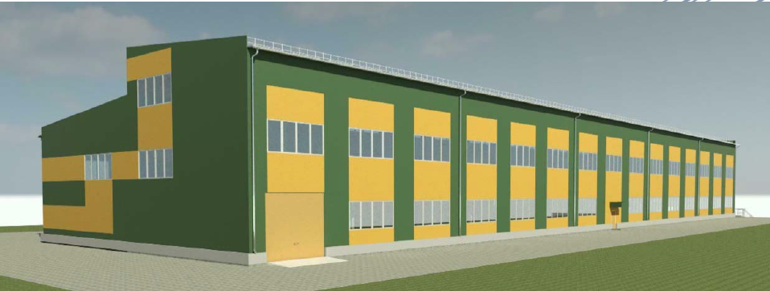
Customer: JSC "RMG Copper".
General data: JSC "RMG Copper" plans to construct a building of industrial importance, the pedestal of which requires thermal insulation and waterproofing.
Description of works:
1. Thermal insulation and waterproofing of the building's pedestal must be performed in full compliance with the applicable standards in this field;
2. Thermal insulation and waterproofing design solutions are included in the above technical specifications, however, the company is also considering more modern and effective solutions for the implementation of these works;
3. The works shall be carried out on an area of ​​approximately 223 sq/m.

The Customer's obligation:
- To grant the Contractor access to the building;
- To provide the Contractor with reinforced concrete structures and architectural designs.

Requirements for the contractor:
- To have experience working in the specified direction;
- To have qualified personnel;
- To submit their own version of technical solutions for the above works (preferably several)
- It is necessary to indicate the price per 1 sq/m for each solution, as well as the estimated time for the full implementation of all works;
- To indicate the warranty period for the work performed.

Attachment:
- Sample design solution for thermal insulation and waterproofing from the architectural design of the building.

