Technical assignment

The following criteria are required for the frame and lid:

Model N1:

- Different inscriptions must be provided so that water supply and sewerage network can be identified without opening the lid.
- The year of manufacture must be marked on the frame cover
- Must be made of cast iron GJS 400-15
- European standard EN 124 class D400, for all types of vehicles for road and pedestrian use
- The material to be supplied is used for A / M roads, therefore it must have a load capacity of 40 tons (confirmed by relevant documents, which must be submitted together with other documents and must meet Georgian and international standards and norms in this field.
- Weight - at least 60 kg +/- 4%
- The frame lid should have a shutter
- The clamp ("stud") must be made of steel
- The frame of the lid should have rubber, thick enough not to cause the noise of the lid
- Any defect caused by the improper quality of the frame cover must be eliminated by the supplier during the warranty period.
- Supplier must provide study/training for correct montage of the goods
- Warrenty period – no less than 10 years.
- Cover height must be 100mm ±4%
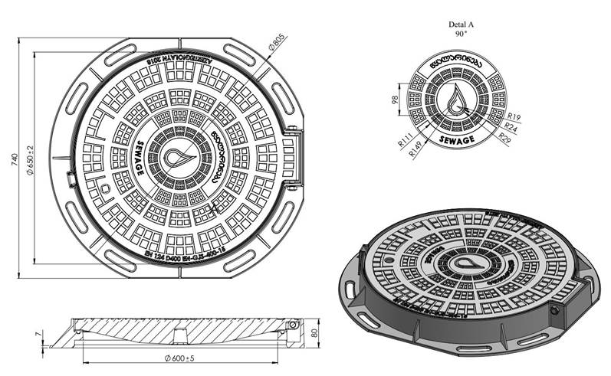

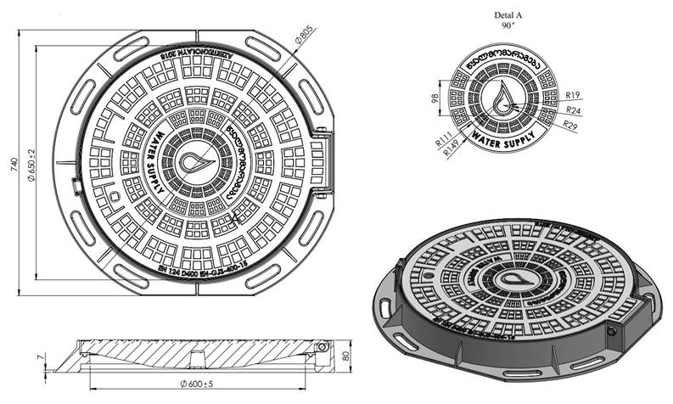

Model N2:

- Different inscriptions must be provided so that water supply and sewerage network can be identified without opening the lid.
- The year of manufacture must be marked on the frame cover
- Must be made of cast iron GJS 400-15
- European standard EN 124 class D400, for all types of vehicles for road and pedestrian use
- The material to be supplied is used for A / M roads, therefore it must have a load capacity of 40 tons (confirmed by relevant documents, which must be submitted together with other documents and must meet Georgian and international standards and norms in this field.
- Weight - at least 65 kg
- The frame lid should have a shutter
- The clamp ("stud") must be made of steel
- The frame lid should have rubber

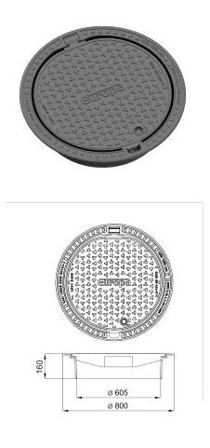

Comments:

- In any cases participants versions will be discussed.

- For all models the driwing, photos and technical datasheets must be provided.

- The brended must be provided in two languages – Georgian and English languages.

