Office Furniture Description | Photo | Price | Number of items in good condition | Offered Price  Gel | Desired Quantity
Desk with extension  desk 180cm*80cm  extension 120cm*62cm |  | 160 ₾ | 14 items
Desk with small extension  desk 180cm*80cm  extension 80cm*62cm | 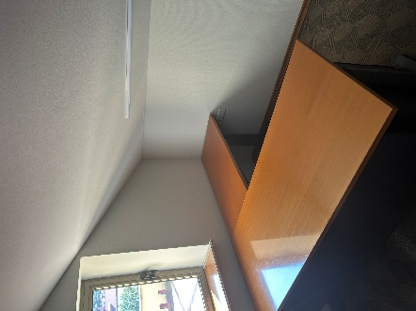 | 115 ₾ | 6 items
Height Adjustable Desk  180cm*80cm |  | 304 ₾ | 2 items
Desk  180cm*80cm | 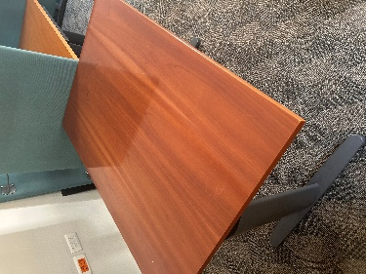 | 230 ₾ | 14 items
Small Desk  120cm*80cm |  | 160 ₾ | 7 items
Very Small Desk  120cm*62cm  (can be used as extensions) |  | 140 ₾ | 6 items
Extensions only  80cm*62cm |  | 80 ₾ | 6 items
CD Desk  front oval shape  210cm*102cm |  | 290 ₾ | 1 item
Round table wooden top  Diameter 120cm | 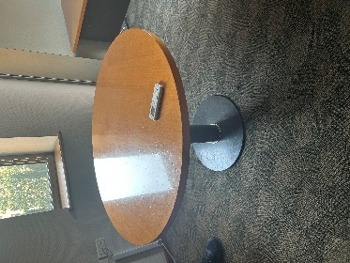 | 280 ₾ | 2 items + 1 slightly scratched
Closet Standard  some with key | 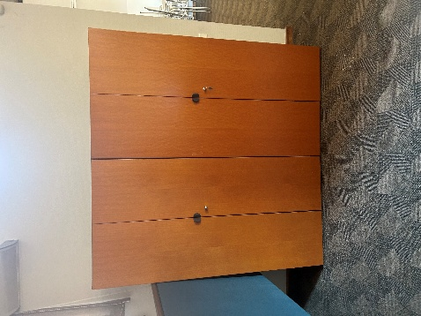 | 220 ₾  --  136 ₾  Without keys | 48 items (+1 without handles)
Closet High  200cm*80cm*44cm | 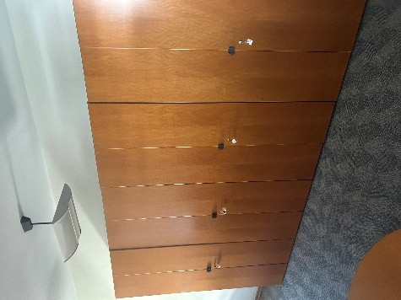 | 220 ₾ | 10 items
Wooden Cabinet  84cm*80cm*43cm |  |  | 2 items
Wooden Cabinet oval front  83cm*225cm*56cm | 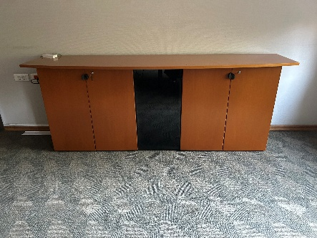 | 360 ₾ | 1 item
Drawer Black  60cm*43cm*60cm  some with key | 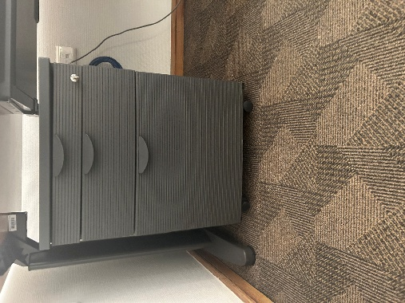 | 140 ₾  --  115 ₾  Without keys | 25 items
Drawer with wooden top  59cm*43cm*60cm |  | 110 ₾ | 22 items
Drawer with wooden top  80cm*43cm*71cm | 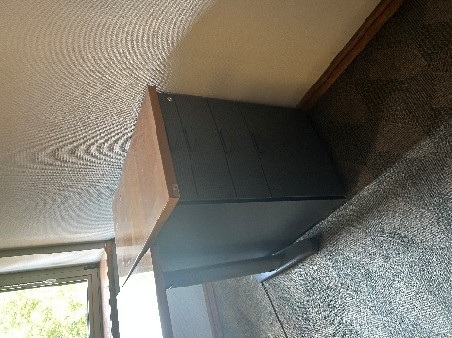 | 120 ₾ | 6 items
Shelves with metal  200cm*100cm*47cm | 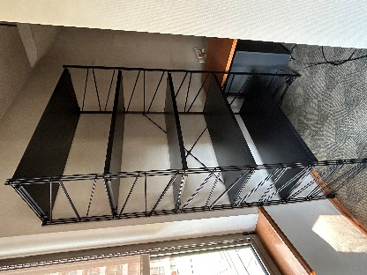 | 300 ₾ | 3 items
Shelves  202cm*80cm*42cm | 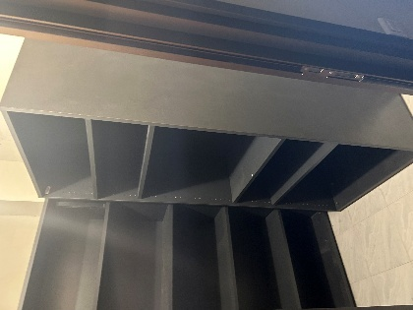 | 100 ₾ | 5 items
Cabinet at the wall  127cm*47cm*45cm  the photo represents three stacked cabinets next to each other | 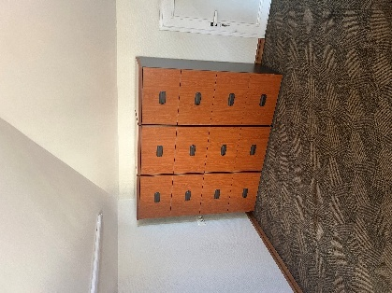 | 100 ₾ | 10 items
Office Chair Adjustable | 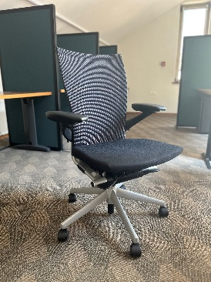 | 160 ₾ | 40 items
Meeting Room Chair Black  stackable | 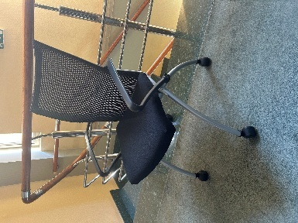 | 200 ₾ | 103 items + 1 slightly scratched
Meeting Room Chair Cream | 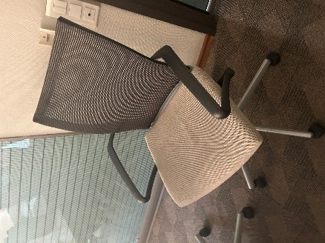 | 150 ₾ | 15 items
Coffee/Journal table  H43cm 70cm*70cm | 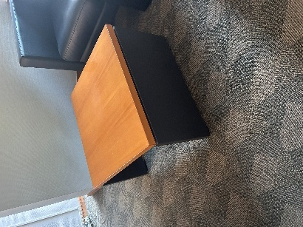 | 50 ₾ | 4 items
2-seat Sofa with Armchair  Blue/Fabric  187cm*88cm / 97cm*88cm | 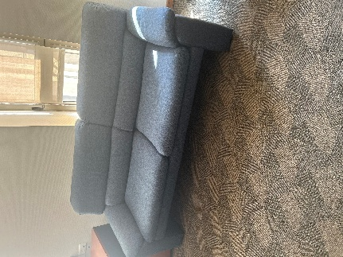  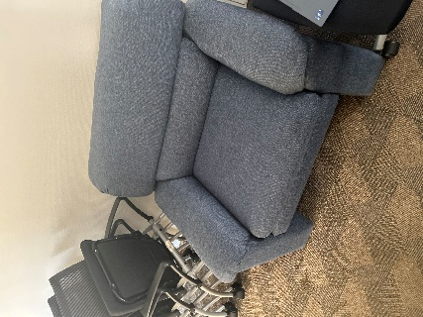 | 190 ₾  --  Armchair  95 ₾ | 1 item
3-seat Sofa with 2 Armchairs  Black/Leather | 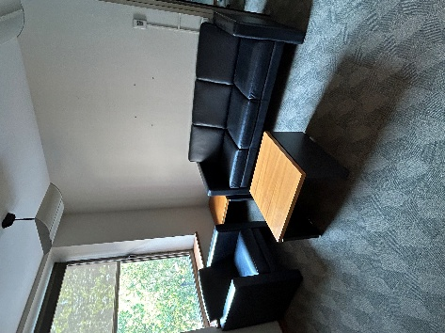 | 640 ₾ | 1 item
2-seat Sofa  Green/Fabric | 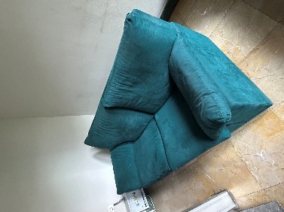 | 300 ₾ | 1 item
3-seat Sofa  Green-Fabric | 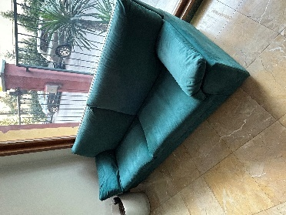 | 370 ₾ | 1 item
Small armchair (almost like a chair) | 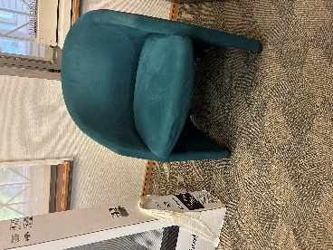 | 110 ₾ | 2 items
Big VC Table  Conjunction of 10 small tables on the wheels 120cm*80cm; finishings on both ends with trapezia desk on two bases 160cm*70cm | 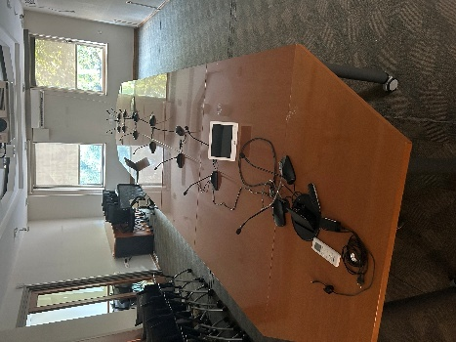 | 1500 ₾  --  One item  200 - ₾ | 1 item? Or 10 items of small tables on wheels
Meeting Room Table  240cm*120cm |  | 240 ₾ | 1 item
Meeting Room Table  200cm*100cm | 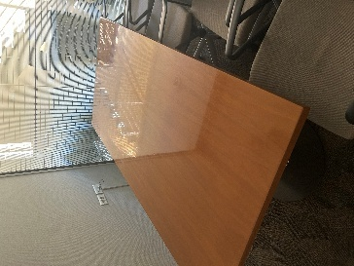 | 210 ₾ | 1 item
Meeting Room Table Oval  250cm*114cm | 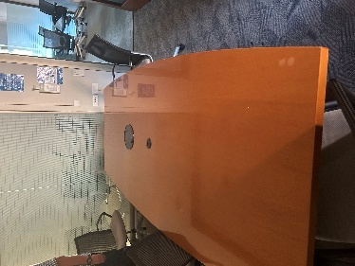 | 280 ₾ | 1 item
Round table for kitchen  Diameter 120cm | 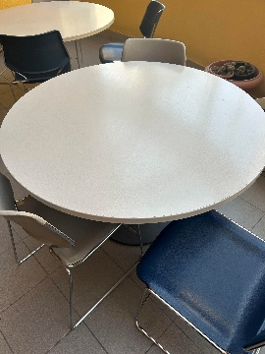 | 200 ₾ | 7 items
Kitchen Table 84cm*65cm*82cm  With granite top and 3 chairs | 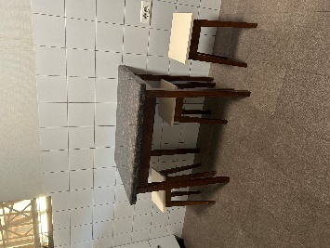 | 280 ₾ | 1 item
Small round table with granite top for kitchen/terrace  Diameter 75cm |  | 160 ₾ | 3 items
Kitchen/Terrace Chairs New | 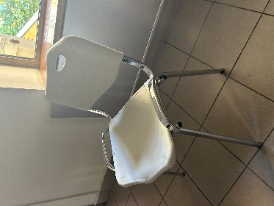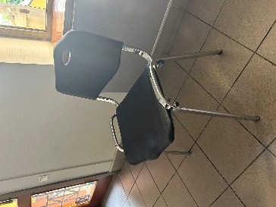 | 64 ₾ | 15 Black  12 Cream
Kitchen/Terrace Chairs Old | 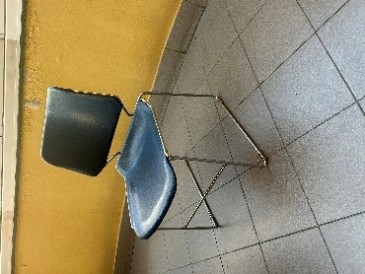  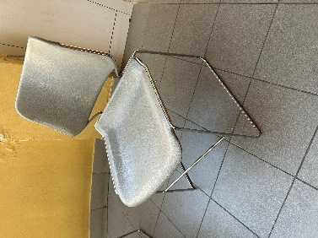 | 140 ₾ | 4 Blue  7 Grey
Dishwasher | 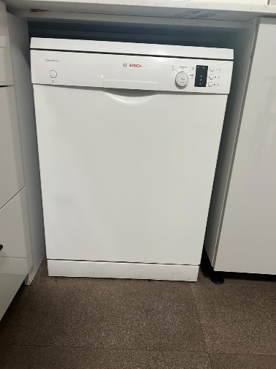 | 350 ₾ | 1 item

Applicant Name
Contact Info
submission date

