Annex N1
Technical Requirements
Product Name
- LIME
Specifications
Richness: 100,00 %CaO Specific mass: 0,90 kg/l
Acceptable Specifications option 1 – preferable option:
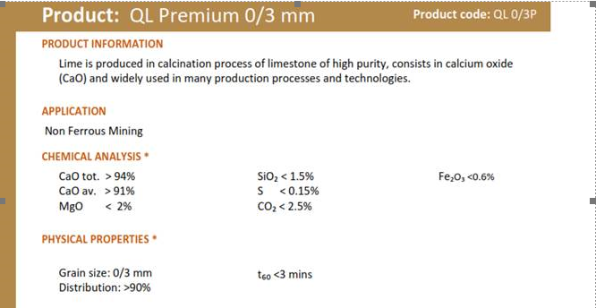
We would like to have the 1st quality product
High CaO values.
Its particule size should preferably be more like a 0 to 1 mm than a 0 to 3 mm

Acceptable Specifications option 2:
Description
Chemical name: calcium oxide
Chemical formula: CaO
Condition: Fine particle powder
Atomic Mass: 56.08
Known as: Lime - slaked and unslaked
Name in accordance with UNE-EN 459: CL 90-Q

Physical characteristics
A single-component substance, calcium oxide, ერთკომპონენტიანი ნივთიერება, კალციუმის ოქსიდი, which contains a small percentage of SiO2, Al2O3, Fe2O3, MgO and CaCO3; It is a raw material of natural limestone. The natural product is obtained by calcination at 1200 ºC, approximately CaCO3.
Appearance | white color, dry, odorless, strong hygroscopic nature
Crystal structure | cubic
PH | 12.4 saturated solution at 25ºC
Density | 940 gr/l
Boiling temp. | 2.850 ºC
Cooling temp. | 2.600 ºC
Weight | 3,34 kg/l 20 ºC
Solubility H2O | soluble in acid, glycerin and sucrose solutions
Reaction with acid | formation of calcium salts by exothermic reaction
Reaction with water | calcium hydroxide is produced during the reaction

Technical data marginal volume
CO2 1 % ≤ 3
Total CaO 97 % ≥ 93
Reaction with water 60ºC 4:00 min ≤ 10
SiO2 0.2 % ≤ 0.7
Al2O3 0.2 % ≤ 0.3
Fe2O3 0.15 % ≤ 0.3
Mg O 1 % ≤ 1.2
Combined H2O 0.1 % ≤ 0.3
S 0.5 % ≤ 0.6

Granulometry:
Sieving Method 5 mm 0 %
Sieving Method 2 mm <12 %

USAGE
The product is used in agricultural, industrial, environment-related activities and livestock farming. For environmental pH and water hardness regulation, remineralization, metal removal, treatment plant and general drinking, industrial or sewage/waste water treatment. For gas treatment of waste fuel and thermal power stations. For soil sabilization, for preparation of construction slurry.
Lime is used for various purposes: neutralizing, melting, caustic, scouring, drying, absorbing, disinfecting, waterproofing and of course as a raw material.

Regulations
UNE-EN 459 - part 1, 2, 3 | Limestone for construction
UNE 80502:2003 | Application of slaked or hydrated lime for soil improvement/stabilization
UNE 80503:2001 | Use of calcium hydroxide in asphalt mixtures
UNE-EN-12518 | In chemical products used for the treatment of water for human consumption - limestone
UNE-EN-12485 | In chemical products used for the treatment of water for human consumption - calcium carbonate, limestone, semi-calcined dolomite

Chemical Abstracts Service Registry Number 1305-78-8
European Invertory of Chemical Substances 215-138-9

Special requirements for shipment - Compulsory
Delivery should be done Bulk in a specialized tanker (Silo truck incl. hydraulic discharge) from which the lime can be fed directly to SILO
Silo loading pressure is 1bar max.
Silo capacity - max. 42 m³
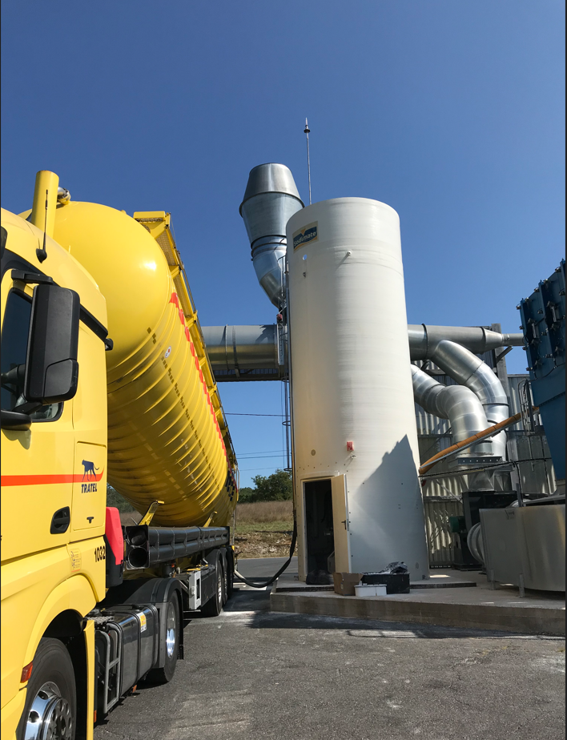

SILOTRUCK should by all means have all the necessary devices (pumps or air impeller) to charge our SILO.
S
Connection to SILO
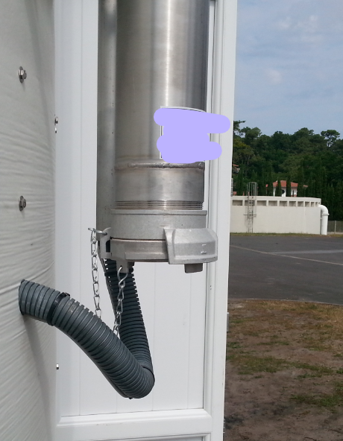

Dimensions of the flange needed
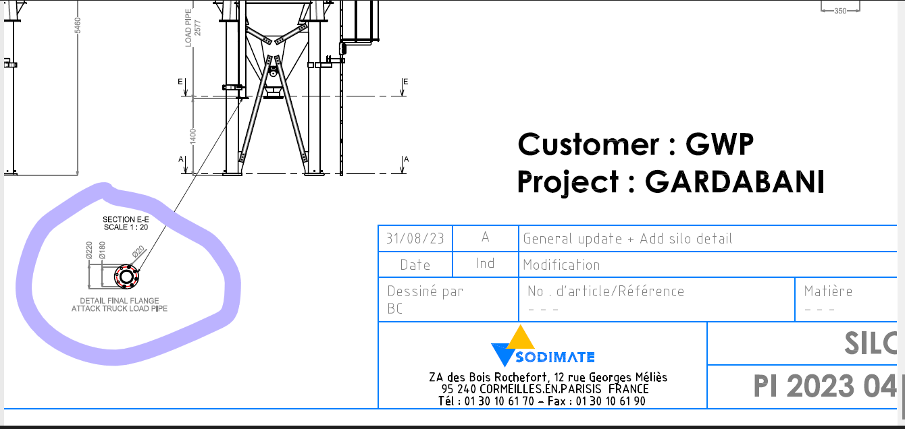
Example video for SILOBUS discharging process –please download:
https://we.tl/t-Okzm8UyPmS
Real photos:

