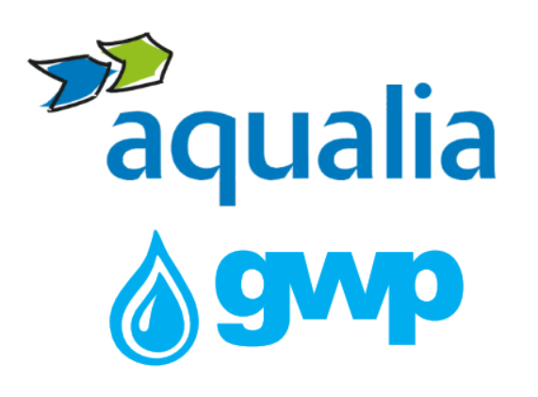

. Electron Tender Documentation for Procurement of
Implementation of the Chlorination and Safety System at Nasaguri Reservoir

    - Procurement object

“Georgian Water & Power” LLC (GWP) (hereinafter referred to as the Buyer) announces e-tender for purchasing Implementation of the Chlorination and Safety System at Nasaguri Reservoir (hereinafter referred to as the Goods and Services) and invites qualified companies to participate therein.

The aim of the tender is to select one company (hereinafter referred to as the Supplier) which will be able to ensure the delivery and the installation of the Goods steadily in 2026 year.

1.2. Description of service / work (technical assignment), quantity / volume of the procurement object

The main goal of the project is to implement the chlorination system at Nasaguri Reservoir.
The proposal fully cover the following:
- The project design with detailed information;
- The equipment with detailed description and datasheets.
- Guarantee period no less than 3 years, which contains the site visits under schedule.
- Training and Maintenance Service
The detailed technical assignment of the project is given as attached file – Technical assignment.
Note: Currently, there is no existing chlorination system or dedicated building on site; therefore, the recommendations concerning the construction of a new facility will be taken into consideration.
  - Form and place of delivery of goods and service
Place of delivery for goods: 7 Tskalsadeni Str. Tbilisi, Georgia. Georgian Water and Power Ltd (GWP) warehouse and/or on side.

  - Pricing

The BOQ of the project might be given in excel file and in PDF file.

1.4 Payment terms
Payment will be made by consignment, with non-cash payment within 30 (thirty) calendar days after receiving the goods and signing of the relevant acceptance certificate and / or relevant documents.

In case of requesting an advance payment (no more than 30% of the total cost of the project), you must submit an advance payment guarantee, which must be issued by a bank licensed by Georgia or a bank of a member country of the Organization for Economic Cooperation and Development (OECD) – can be negotiable.

1.5 Data to be uploaded / submitted by the bidder in the electronic tender:
1. Price with full information (excel and pdf files) included all fees and estimate delivery/implementation date.
2. A brief overview of the project plan (P&ID): objects reconstruction requirements, goods description and installation plans.
3.Information on the materials used Quality certificates issued by the relevant authorities.
4. The warranty must apply to the material and guarantee to the installation service according to the technical assignment.
5. The supplier must present the quality certificates corresponding to the country where the material will be produced (if any).
6. Extract from the Register of Entrepreneurs and Non-Entrepreneurial (Non-Commercial) Legal Entities, which must be issued no later than 3 months before the announcement of this electronic tender.
7. In case of participation of foreign companies, the relevant document confirming the signature of the person involved in the procurement process must be attached:
(a)A recent company extract from the national business registry or equivalent authority in your country of residence.
(b)A notarized and valid power of attorney granting signing authority.
(c)A board or shareholders’ resolution confirming the appointment and powers.
(d)If applicable, any other document that can confirm the appropriate authority.
Please ensure that the documents are duly signed and, if applicable, notarized and translated into English.
12. Fully filled Company’s questionaries (2 files given as the attached files)

Note:
- All documents and / or information created by the bidder uploaded in the electronic tender must be signed by an authorized person (if necessary, a power of attorney must be uploaded);
- All documents and / or information created by the bidder must be confirmed by the electronic signature of the authorized person or the electronic stamp of the company.
- If the bidder is a foreign enterprise that is not registered in Georgia, bidder can send the bid via e-mail, which is indicated in the contact information of this tender documentation.

1.7 Signing a contract
Within the this e-tender, a single contract will be concluded.

1.8 Other requirements
1.8.1 At the time of submission of the proposal, the bidder should not be:
• in the process of bankruptcy;
• In the process of liquidation;
• In a state of temporary suspension of activities.
1.8.2 Presentation of prices is allowed only in the national currency of Georgia (GEL). Prices should include all costs and taxes (including VAT) provided by this tender.
1.8.3 The bid submitted by the bidder must be valid for 90 (ninety) calendar days from the date of receipt of bids.
1.8.4 The Procurer (Georgian Water and Power LLC (GWP, JSC 203826002) reserves the right to set the deadline for the tender, change the terms of the tender, notify the tender participants in a timely manner, or terminate the tender at any stage.
The Procurer (Georgian Water and Power Ltd (GWP, ID 203826002)) will identify the winning supplier to the Tender Commission and notify all participating companies of the decision. The Purchaser (Georgian Water and Power Ltd (GWP, ID 203826002)) is not obliged to provide the participating company with a verbal or written explanation of any decision regarding the competition.
The Purchaser (Georgian Water and Power LLC (GWP, ID 203826002)) reserves the right to verify any information received from the Bidders, as well as to obtain information about the Bidder Company or its activities. If it is proved that the information provided by the bidder is not true or falsified, the bidder will be disqualified.
Please note that the Purchaser (Georgian Water and Power Ltd (GWP, ID 203826002) will not receive any oral inquiries for additional information, except by telephone.
Note: Any other information obtained by other means will not be official and does not give rise to any liability on the part of the Purchaser (Georgian Water and Power LLC (GWP, ID 203826002)).

1.9 Information for e-tender participants
1.9.1 Any questions during the tender process must be in writing and the online Q&A mode of tenders.ge portal must be used;
1.9.2 To participate in the electronic tender, the company must be registered on the website www.tenders.ge
1.9.3 Instructions for participation in the electronic tender on tenders.ge can be found in the attached file
1.9.4 The participation in the tender if free of charge.

I got acquainted
/ Signature of the authorized person of the participating company /

Responsible Person: Georgian Water and Power LLC (GWP), with Company ID 203826002, for personal data protection purposes - Personal Data Protection Officer, Head Office, 10 Medea (Mzia) Jugheli Street, Tbilisi 0179, Georgia, contact e-mail: pdpo@gwp.ge. Purpose of Data Processing: To carry out an open-source analysis on the third party to assess the compliance risks in the potential relationship with said third party. Legitimation: Professional and/or commercial relationship. Recipients: Your data will not be transferred to any third party, except in compliance with a legal obligation or a legal right. Retention: Your data will be kept for the time necessary for the analysis of the company and, for the period of contractual relationship. Once completed, your personal data will be blocked during the periods allowed by laws. Once these periods have elapsed, they will be destroyed. Rights: You can exercise your rights of access, rectification, renewal, deletion, limitation or opposition to treatment and withdraw the consent given, by writing identified with the reference "Data Protection" to: Personal Data Protection Officer, Georgian Water and Power LLC, 10 Medea (Mzia) Jugheli Street, Tbilisi 0179, Georgia or by sending an e-mail under the same terms specified to: pdpo@gwp.ge, in which you must specify the right you are exercising and be signed by you (either physically or electronically) or provide necessary information to be able to identify you. If we are unable to identify you, we may request additional information, including without limitation a copy of your ID card. The interested parties have the right to complain to the Personal Data Protection Service (www.personaldata.ge).

Contact information:
Procurement Team Leader
Ketevan Kandelaki
Address: 10 Medea (Mzia) Jugeli str., 0179, Tbilisi, Georgia
E-mail: kekandelaki@gwp.ge
Tel.: +995 599 19 25 00

Technical contact person:
Gia Magradze
Address: 10 Medea (Mzia) Jugeli str., 0179, Tbilisi, Georgia
E-mail: gmagradze@gwp.ge
Tel.: +995 595 67 67 39

