Required product: Factory Made Booster set for municipal water supply 1+1 with control panel; H 110m; Q 120 m3/h for each pump
Quantity: 1 Factory Made Booster set with control panel and 100 liters expansion tank
Supervision of commissioning and start-up should be included in the price
Shaft correction should be included in the price if necessary
Total Set should include:
2 pumps + Asynchronous Motor
Frame; Suction/discharge manifold complete with flanges and check valves
Pump Control panel with Modbus RTU communication module
Expansion Tank – 100 liters
And all other necessary parts to ensure proper operation of the Booster set for municipal water supply
Requirements for pumps and motors:
Pump type: Centrifugal.
Application type: Drinking water.
Pump capacity: 120 m³/h. for each pump
Pump elevation head: 110 m.
Motor type: Asynchronous.
Voltage Rating: 0.4 Kv; 3X380VAC
Rpm: 1500/3000
Motor control: VFD

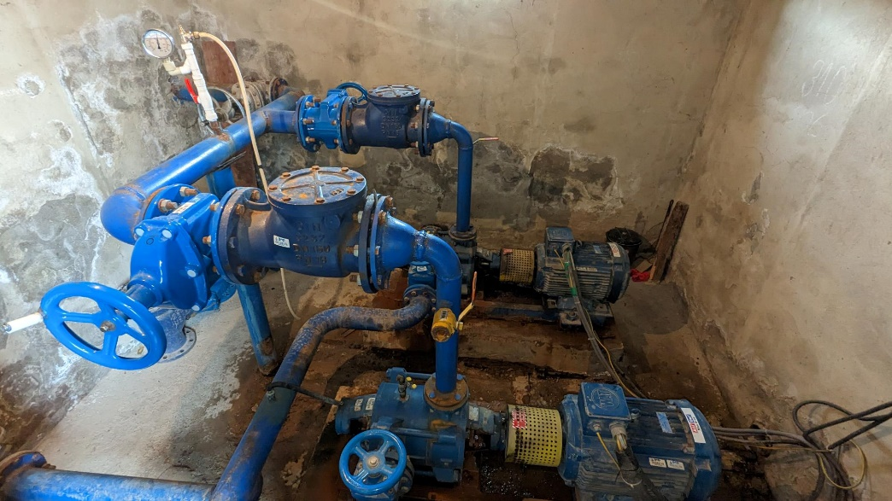

Requirement for control panel:
Required material: Booster set Control panel (Factory made)
Quantity: 1 set (according to offer pump powers)
Panel rated voltage: 0.4 Kv; 3X380VAC
Motor Control method: VFD
Communication Module: Modbus RTU
Panel Features:
- Reservoir Level control
- Soft pressure build-up (To prevent water hammer during startup).
- Pipe filling function.
- Selection of automatic pump changeover and pump
priority.
- Auto/Manual operation.
- Emergency stop button accessible on the control panel.
- Possibility of external setpoint influence.
- Log function.
- Possibility of digital remote-control functions:
- Support for communication fieldbus protocols (Modbus, Profibus, or Ethernet/IP).
- HMI
- Control Panel minimum protection type IP54.

