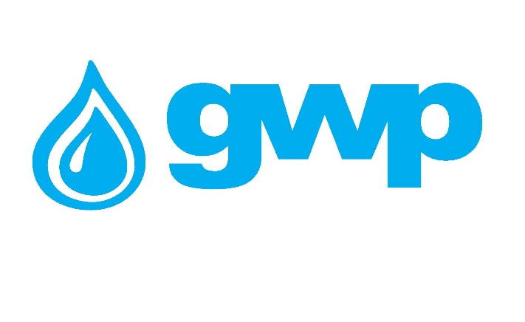

Electronic Tender Documentation

Purchase of the Consultancy Services for the construction project engineering and implementation of new physical-chemical treatment in Ghrmaghele WTP, modifying the current rectangular clarification to new lamellar sedimentation process

1.1 Name of the procurement object
Georgian Water and Power LLC (GWP) ID 203826002 announces an electronic tender for the purchase of Consultancy Services for the construction project engineering and the implementation of new physical-chemical treatment in Ghrmagele WTP, modifying the current rectangular clarification to new lamellar sedimentation process.

1.2. Description of service / work (technical assignment), quantity / volume of the procurement object
Detailed terms of reference are given in Annex N1 (ToR) and in Annex N2 - GHRAMGHELE TECHNICAL REPORT

1.3 Payment terms
Payment will be made by consignment, within 30 (thirty) calendar days from the provision of non-cash payment services and the signing of the relevant acceptance acts and/confirmation of the consignment note. However, any kind of prepayment will be done on the basis of Bank Guarantee.

1.4 Instruction to bidders

  - Bidder must request in writing Annex 1 of TOR and submit a signed NDA (non-disclosure agreement), which will be provided by Employer upon request.
  - BID (Technical and Financial proposal) must be submitted in line with the instructions provided within this tender package.
  - BID Submission Deadline: March 3, 2026, 15:00 (TBS)
  - Financial proposals for the companies registered in Georgia must be prepared and submitted only in national currency (GEL), including VAT. For Non residential companies are allowed in foreign currency EUR/USD
  - The bid validity period is 60 (Sixty) calendar days from the date of submission of bids.
  - The Employer (Georgian Water and Power (GWP, JSC 203826002)) reserves the right to set the deadline for the tender, change the terms of the tender or terminate the tender at any stage.
  - The Tender Committee of the Employer will identify the winner of the Tender by the criteria set in this document. Evaluation of the Proposals will be conducted for both parts of the proposal (Technical and Financial Proposals).
  - The Employer reserves the right to award the Contract based on experience, completion date, a guarantee of service, and other criteria, and not necessarily the lowest cost, at the same time, the Employer is not obliged to select a winner based on the lowest price.
  - The Employer is not obliged to disclose any information about the Evaluation process and Tender Committee’s decision and its details to the bidders.
  - The Employer (Georgian Water and Power LLC (GWP, JSC 203826002)) reserves the right to verify any information received from bidders, as well as to obtain information about the bidder’s company or its activities. If it is confirmed that the information provided by the bidder is not true or falsified, the bidder will be disqualified.
  - Communication for clarification must be in a written manner and the online Q&A mode of the tenders.ge portal must be used.
  - Any oral inquiries for additional information are not accepted.
  - The Employer is not responsible for the information obtained from other sources.
  - For participation in the electronic tender, the Bidder must be registered on the website www.tenders.ge
  - Instructions for participation in electronic tender are presented on www.tenders.ge, in the attached file.
  - If none of the bidders participate in the Site visit organized and arranged by the Employer in March, 2026, from 10 am till 17 pm, the Employer has the right to cancel the bidding process and/or not to consider proposals submitted by the bidders, which did not participate in the Site visit. The exact date will be identified after the bidder’s request submitted to email (msilagadze@gwp.ge) The information will be shared to all the bidders submitted respective request.

  - Data to be uploaded / submitted by the bidder in the electronic tender:
- Financial Proposal
- Extract from the Register of Entrepreneurs and Non-Entrepreneurial (Non-Commercial) Legal Entities, which must be issued after the announcement of this electronic tender;
- Consent to these tender conditions, for which a signed tender application must be submitted;
- Information on the services used Quality certificates issued by the relevant authorities.
- Offer must be valid for – 60 (sixty) calendar days.
- At least 5 years of similar project experience – minimum three project descriptions including location, Employer, relevance to the current project. The employer has the right to request Bidder to submit copies of the contract, acceptance certificate and/or similar documents, for the Project presented under this clause.

Note:
- All documents and / or information created by the bidder uploaded in the electronic tender must be signed by an authorized person (if necessary, a power of attorney must be uploaded);
- All documents and / or information created by the bidder must be confirmed by the electronic signature of the authorized person or the electronic stamp of the company.
- If the bidder is a foreign enterprise that is not registered in Georgia, bidder can send the bid via e-mail, which is indicated in the contact information of this tender documentation.
- Also, if some technical problem will arise, during bid submission on tender site, the bidder can send a proposal on the e-mail specified in the tender documents. We would like to state that the proposal must be submitted by e-mail no later than 15:00 on March 3, 2026.

1.5 Signing a contract
After evaluation of the proposals Employer will provide the draft Contract for Service to the most suitable Bidder. If the agreement with Bidder could not be established about the terms and conditions of the contract, Employers has the right to continue negotiations with the second Bidder identified as the most suitable.

1.6 Safety regulations
Bidder must confirm within the BID its agreement for all of Bidder’s workforce and sub-contractors to participate and comply with the Employer’s on-site safety orientation and requirements and all legal regulations of Georgia as applicable. The contracted Bidder/Supplier is obliged to provide his employees and meet with the Health and Safety corresponding standards and norms, to be met during relevant activities conducted on the Employer’s site for fulfilment of services.

1.7 Other requirements
1.7.1 At the time of submission of the proposal, the bidder should not be:
- in the process of bankruptcy;
- In the process of liquidation;
- In a state of temporary suspension of activities.
1.7.2 Presentation of prices is allowed only in the national currency of Georgia (GEL). Prices should include all costs and taxes (including VAT) provided by this tender.
1.7.3 The bid submitted by the bidder must be valid for 30 (thirty) calendar days from the date of receipt of bids.
1.6.4 The Procurer (Rustavi Water LLC (RWC, JSC 216323351) reserves the right to set the deadline for the tender, change the terms of the tender, notify the tender participants in a timely manner, or terminate the tender at any stage.
The Procurer (Georgian Water and Power Ltd (GWP, ID 203826002)) will identify the winning supplier to the Tender Commission and notify all participating companies of the decision. The Purchaser (Georgian Water and Power Ltd (GWP, ID 203826002)) is not obliged to provide the participating company with a verbal or written explanation of any decision regarding the competition.
The Purchaser (Georgian Water and Power LLC (GWP, ID 203826002)) reserves the right to verify any information received from the Bidders, as well as to obtain information about the Bidder Company or its activities. If it is proved that the information provided by the bidder is not true or falsified, the bidder will be disqualified.
Please note that the Purchaser (Georgian Water and Power Ltd (GWP, ID 203826002) will not receive any oral inquiries for additional information.

Note: Any other information obtained by other means will not be official and does not give rise to any liability on the part of the Purchaser (Georgian Water and Power LTD (ID 203826002) and Gardabani Sewage Treatment Plant LLC (ID 203828313).

Responsible Person: Georgian Water and Power LLC (GWP), with Company ID 203826002, for personal data protection purposes - Personal Data Protection Officer, Head Office, 10 Medea (Mzia) Jugheli Street, Tbilisi 0179, Georgia, contact e-mail: pdpo@gwp.ge. Purpose of Data Processing: To carry out an open-source analysis on the third party to assess the compliance risks in the potential relationship with said third party. Legitimation: Professional and/or commercial relationship. Recipients: Your data will not be transferred to any third party, except in compliance with a legal obligation or a legal right. Retention: Your data will be kept for the time necessary for the analysis of the company and, for the period of contractual relationship. Once completed, your personal data will be blocked during the periods allowed by laws. Once these periods have elapsed, they will be destroyed. Rights: You can exercise your rights of access, rectification, renewal, deletion, limitation or opposition to treatment and withdraw the consent given, by writing identified with the reference "Data Protection" to: Personal Data Protection Officer, Georgian Water and Power LLC, 10 Medea (Mzia) Jugheli Street, Tbilisi 0179, Georgia or by sending an e-mail under the same terms specified to: pdpo@gwp.ge, in which you must specify the right you are exercising and be signed by you (either physically or electronically) or provide necessary information to be able to identify you. If we are unable to identify you, we may request additional information, including without limitation a copy of your ID card. The interested parties have the right to complain to the Personal Data Protection Service (www.personaldata.ge).Note: Any other information obtained by other means will not be official and does not give rise to any liability on the part of the Purchaser GWP

I got acquainted
/ Signature of the authorized person of the participating company /

Contact information:
Water and Power Production Director
Contact person: Víctor José Solís Gutiérrez,
E-mail: vjsolisg@aqualia.com

Procurement Team Leader
Contact person: Mariam Silagadze
Address: Georgia, Tbilisi, Mtatsminda district, Medea (Mzia) Jugheli street, №10
E-mail: msilagadze@gwp.ge
Tel: +995 322 931111 (1147); +995 599 72 30 03

