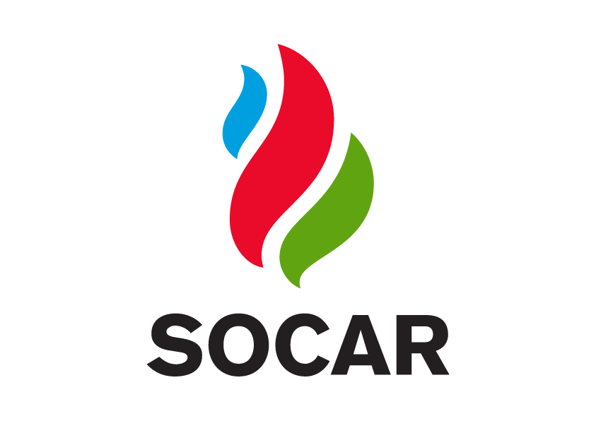

REQUEST FOR PROPOSALS
ESG Strategy and Roadmap Development

Background
SOCAR Energy Georgia is seeking qualified consulting agencies to support the development and implementation of a comprehensive Environmental, Social, and Governance (ESG) strategy. The initiative aims to strengthen sustainability performance, improve access to financing, align with international reporting frameworks and SOCAR HO sustainability strategy, and enhance organizational ESG governance.
This RFP is issued to invite proposals for professional advisory and implementation support in line with SOCAR Energy Georgia’s sustainability objectives and global strategy.

Objectives
The selected agency will support SOCAR Energy Georgia in:
- Assessing current ESG performance and maturity
- Developing a structured ESG strategy and roadmap
- Supporting governance, data, and reporting frameworks
- Defining measurable and achievable KPIs
- Supporting organizational alignment with the SOCAR HO strategy and capacity building

Scope of Services
The scope of work is expected to include, but is not limited to:
Current-State Assessment
- ESG diagnostics and gap analysis
- Benchmarking against relevant peers (in terms of business model, budget, scope) and best practices
- Identification of improvement areas and priorities in line with the SOCAR HO ESG Strategy
Strategy Development
- ESG vision, priorities, and strategic objectives supporting SOCAR HO’s sustainability roadmap
- Roadmap and implementation timeline
- Alignment with relevant frameworks and SOCAR HO sustainability strategy
Governance
- ESG governance structure
- Roles and responsibilities
- KPI and performance management system
Targets and Measurement
- SMART targets and milestones to be cascaded with the vision from HO level Targets
- Monitoring and reporting mechanisms
Capacity Building
- Internal stakeholder engagement
- Project communication plan
- Knowledge transfer and training

4. Deliverables
Expected deliverables include:
- ESG maturity assessment report
- Benchmarking and gap analysis
- ESG strategy and roadmap with the timeline
- Governance and KPI’s
- Implementation guidelines
- Final project report and recommendations

5. Proposal Submission Requirements
Interested agencies must submit a proposal including the following components:

5.1 Technical Proposal
- Understanding of project objectives
- Proposed methodology and approach
- Work plan and timeline
- Key risks and mitigation measures

5.2 Financial Proposal
- Detailed service budget
- Cost breakdown by phase and deliverables
- Payment schedule

5.3 Company Information
- Legal name and registration details
- Company profile and years of operation
- Relevant certifications and accreditations
- Previous experience in ESG/sustainability projects

5.4 Team Credentials
- Project team structure
- CVs of key experts
- Relevant project experience
- Allocation of responsibilities

6. Evaluation Criteria
Proposals will be evaluated based on:
- Technical quality and methodology
- Understanding of SOCAR’s ESG Strategy
- Relevant experience and references
- Qualifications of the team members
- Cost-effectiveness and value for money
- Ability to deliver within the required timeframe

9. Confidentiality and compliance
All information provided by SOCAR Energy Georgia within this RFP and during the selection process must be treated as confidential.
Selected offers will be subject to SOCAR Energy Georgia’s internal compliance, integrity, and due diligence screening procedures. This may include, but is not limited to, background checks, sanctions screening, conflict-of-interest assessment, and verification of legal and financial standing.
Failure to meet the Company’s compliance requirements may result in disqualification at any stage of the procurement process

