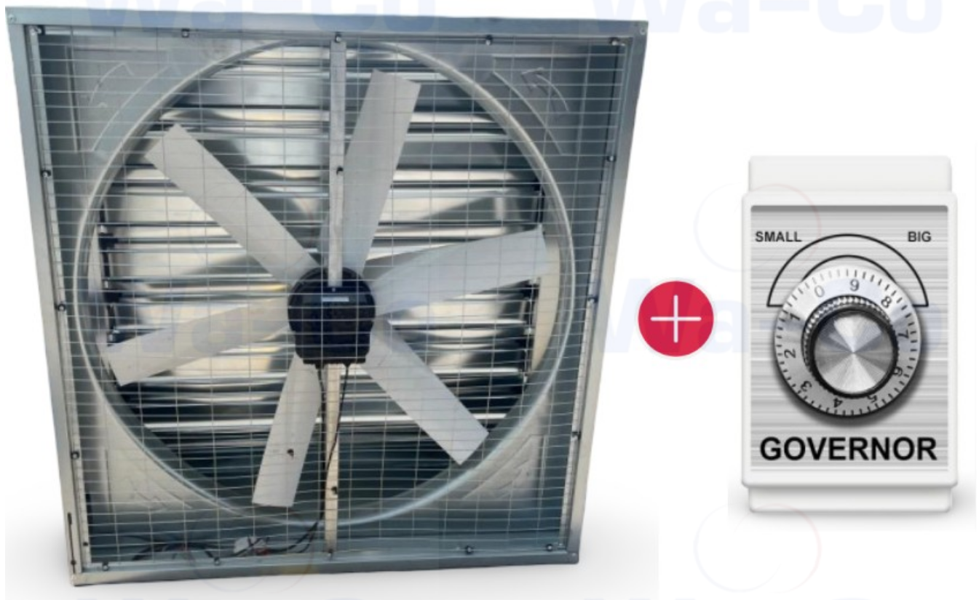

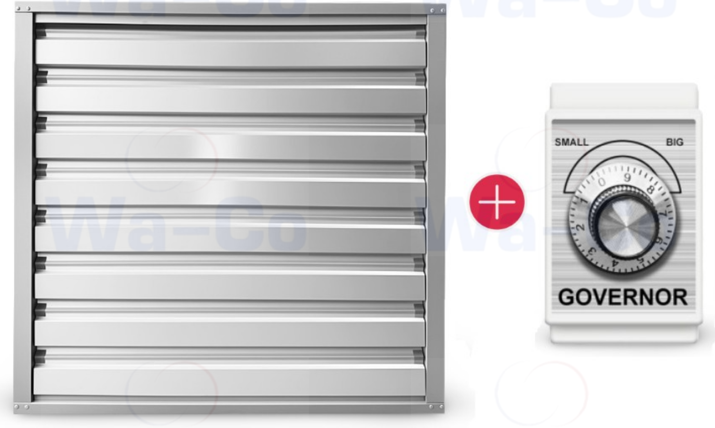

TECHNICAL SPECIFICATIONS
- Airflow, m³/h: 32,000
- Dimensions (mm): 1060 × 1060
- Blade Diameter (mm): 910
- Connection Type: End connection, installation in wall opening
- Axial Fan Type: Industrial with shutters
- Motor: Synchronous (EC)
- Voltage, V/Hz/Ph: 380 / 50 / 3
- Rotational Speed, rpm: 540
- Noise Level, dB: 68
- Power Consumption, kW: 0.75
- Drive Type: Direct
- Rotation Speed Controller: Included
- Housing Material: Galvanized metal
- Blades: Stainless steel
- Shutters: Chrome-plated / galvanized steel
- Inertia Shutters: Yes
- Shutter Opening Mechanism: Inertia or mechanical
- Mechanical Ventilation Mode: Manual shutter opening with locking
- Advantages:
  - EC motor – at least 30% energy savings
  - Speed controller included
  - Direct drive
  - Ability to manually open shutters when the fan is off

