დანართი #1 (საქონლის სპეციფიკაცია)

1 Dispensing cassette standard CMD-V4
The cash-out cassettes are made of polycarbonate. A space of up to 310 mm (the maximum filling height) is available to accommodate banknotes, i.e. approx. 2.500 new notes (depending on their thickness). The cassette can handle all customary banknotes with widths between 54 and 85 mm and lengths between 92 and 182 mm. Each cassette has its own carrying handle and is fitted with a latch. The design of the dispensing cassette is especially robust owing to its integrated handle and its constructive design. It is thus very well suited for daily use. The integration of a “stepper motor“ in the dispensing cassette ensures continual and even pressure on the banknotes, which enables optimal dispensing of the banknotes from the cassette, right down to the very last banknote. This is not possible in cassettes that are equipped with a simple spring, such as those used by our competitors. By default, all cassettes are sealable.

Technical data
Data stored: | Currency, denomination and number of banknotes
Pressure regulator for banknotes: | electronic
Banknote capacity: | Appr. 2.500 new banknotes
Dimensions (WxHxD): | 260 x 125 x 440 mm
Weight empty: | appr. 2,5 kg
Width of banknotes: | 54 – 85 mm
Length of banknotes: | 92 – 182 mm
Thickness of banknote: | 0,08 – 0,12 mm
Weight of banknote: | 70 – 120 g/m²

1.1 1750109646
Cash out cassette w/o lock, sealable for CMD-V4 dispenser
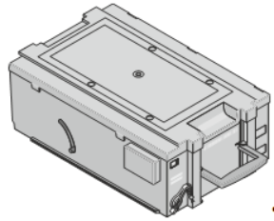
Figure 9 Chash out cassette without lock sealable

2 Reject/retract cassette CMD-V4/V5
With the Reject- / Retract cassette the CINEO system family offers our customer maximum flexibility regarding the handling von special note stacks like retained customer money or selective rejected notes of e.g. bad quality. These features facilitate a higher system availability.
For all Self-Service Cash Dispensing systems a two compartment cassette is available with the option for a flexible configuration for each compartment.
This cassette has generally two key functions:
The storage of one retract (customer owned money): These are banknotes that were retained from the customer after a configurable timeout.
The storage of several rejects (bank owned money): These are e.g. „bad quality“ banknotes which cannot be processed by the system. To increase system availability the system rejects these notes. It is possible to process both single and bundle rejects to enable a maximum efficient note processing.

The two compartment RR-cassette for cash Dispensing systems offer an overall capacity of up to 500 banknotes. The individual compartments can store 100 / 400 banknotes.

Capacity of retract compartment: | Approx. 100 banknotes
Capacity of reject compartment: | Approx. 400 banknotes
Dimensions (W x H x D): | 253 x 118 x 260 mm
Width of banknotes: | 54 – 85 mm
Length of banknotes: | 92 – 182 mm

2.1 1750041920
Reject-retract cassette without lock
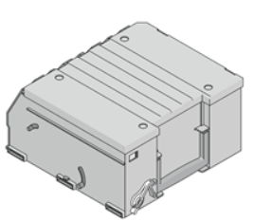 | Type:  “Basic” with two compartments  Features:  Lead-sealable

ფასების ცხრილი

დასახელება | რაოდენობა | ერთეულის ფასი | ჯამური ღირებულება
Dispensing cassette standard CMD-V4 | 400 |  | $0.00
Reject/retract cassette CMD-V4/V5 | 100 |  | $0.00
Total |  | $0.00

კომპანიის დასახელება და საიდენტიფიკაციო კოდი

უფლებამოსილი პირის ხელმოწერა _______________
საკონტაქტო ნომერი:

